Game Name

Published By:

Joseph Goodman, Joseph St. Andre and Shane Crowe

Developed By:



Using this template, you’ll compile the details that make your group’s game what it is. You’ll do the following:

* **Keep the headings (marked in blue)** - they’re necessary to the document’s flow and are bookmarked.
* Replace the placeholder text/images as you go. **Each member** of the **group should** have a **unique color** for their **new contributions** for a **given version**. Once a subsequent version is uploaded, the previous uniqueness of edits can be uniformly colored.
* Pay special attention to areas marked in **red** by me; while many areas offer you freedom of representation, these are less negotiable.
* After each date of edit, summarize changes in the table below, making sure to mark who changed them.
* You will occasionally upload this file to Schoology. This will mark the end of one version of the document, named “[Name of your Game]_GDD_[Version #]”. For example, mine could be **Platypusimulator_GDD_0.0.6**.
* *Text marked in italics are examples which you will replace with content relevant to your game.*

Revision: 0.0.1

# Document History

|  |  |  |  |
| --- | --- | --- | --- |
| **Version** | **Date** | **Summary** | **Author(s)** |
| 0.0.1 | 1/1/2020 | Initial Draft | Double Coconut |
| 0.0.2 | 2/27/25 | Beginning Input | Joseph Goodman, Mr. Crowe |

Document History

Game Summary

Target Platform(s)

Business Model

Game Overview

Theme / Setting / Genre

Core Gameplay Mechanics

Server / Online Mechanics

Push Notifications

Story and Gameplay

Story

Core Gameplay

Meta-Games

User Interface / Screens

Main Menu

Gameplay Screen

Premium Currency Store

Coins Store

Gear Shop

Settings Popup

Daily Reward Popup

Game Over Screen

Levels

Level Design Tools

First Time Experience

Economy

Asset List

Associated Documents

# 

# Game Summary

A quick summary of the game / high level big picture.

The king has been acting strange and fired you from knighthood. You return to the castle to explore what is wrong with the king and get to the bottom of everything strange going on by sneaking in the castle, utilizing tools and solving puzzles.

* Top-Down pixel
* Medieval Espionage
* Dynamic usage of items/tools
* Puzzles

## Target Platform(s)

* PC

## Business Model

*This will be a free to play game*

# Game Overview

## Medieval-Dark Fantasy / Castle / action-adventure Stealth

Show some example images or similar games / movies / books / TV shows with similar themes.

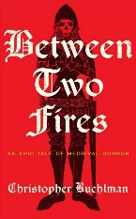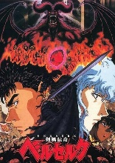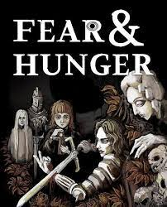

## Core Gameplay Mechanics

Similar to Metal Gear

* Different tools specific to the time and work differently than the ones in Metal Gear
* Unique monsters that have to be delt with differently

## Server / Online Mechanics

* Account With Cloud Save
* Weekly Leaderboard
* Server-Side Data / Settings
* Etc.

## Push Notifications

If any...

# Story and Gameplay

## Story

The king has been acting strange and fired you from knighthood. You return to the castle to explore what is wrong with the king and get to the bottom of everything strange going on by sneaking in the castle. As you delve further into the castle you come to find that everything is controlled by supernatural malevolent forces worse than any demon that could be imagine with the core of it all growing underneath the kingdom and now you must destroy it

Explain how the story will be told – Cutscenes and textboxes

## Core Gameplay

A description of the game ‘loop.’

You start off sneaking and exploring which can lead to puzzles, fighting or avoiding traps where you can find loot, go back to sneaking/exploring or progress the story

A flowchart is required:

## Meta-Games

Variables or systems that work such as upgrading characters, etc.

More flowcharts!

# User Interface / Screens

Wireframes of **every** screen or popup in the game and clear info on how they connect and lead to each other.

Numbering these sections makes them easy to find and you may even want to make a master flow-chart with ALL screens showing how each connects to the other.

## Main Menu

* *Game Logo*
* *“Play Now” Button - Goes to 2. Gameplay Screen*
* *“Store” - Goes To 3. Premium Currency Store*
* *“Settings”*
* *“Credits”*

## Gameplay Screen

123

+

Settings (See “6. Settings” Popup)

Gear Shop (See “5. Shop” Screen)

Coin (Soft Currency) Balance

Coin Store (See “4. Coin Store” Screen)

Level / Progress to Next Level

Player Hit Points

Enemy Hit Points

Open Daily Reward Chest

(See “7. Daily Reward” Popup)

5



## Premium Currency Store

You know what to do here!

## Coins Store

Maybe different from a premium store.

## Gear Shop

Lala.

## Settings Popup

Pop Ups too!

## Daily Reward Popup

Pop Ups too!

## Game Over Screen

And more!

# Levels

Details about how many levels.

How levels will vary.

An example of a beginner level.

An example of a complex level.

A graph of the level “curve” which is usually starting easy as the player learns the game, getting a bit more difficult until the player faces off against a nerve-wracking “boss fight” or “challenge gate”, then sawtooth down to a bit easier again to let players relax.

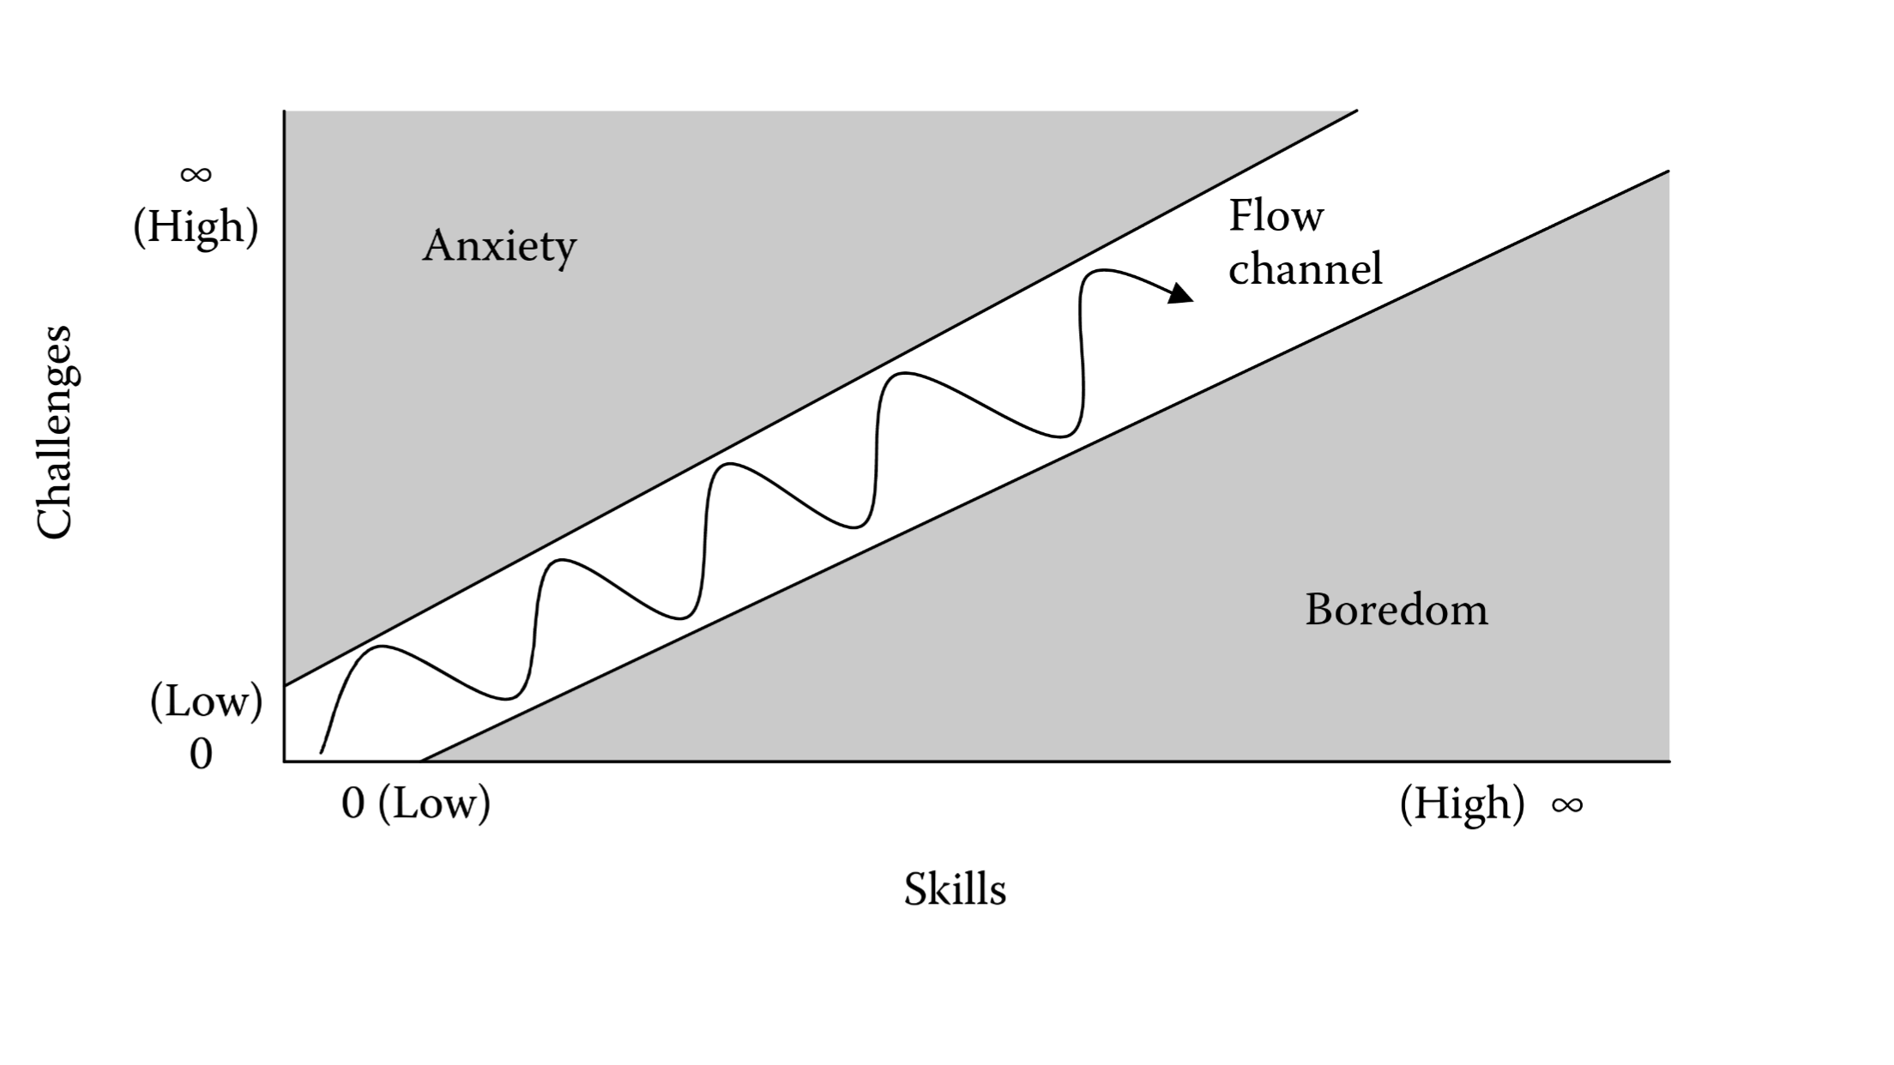

# Level Design Tools

For example, is a tool needed for a designer to create and play-test levels?

How does it work exactly?

# First Time Experience

Step by step.

Details of how a new player learns your game.

# Economy

Link to Spreadsheet with tabs for all economy details. Such as:

* Info about premium currency:

|  |  |
| --- | --- |
| ***USD*** | ***Coins*** |
| *$0.99* | *100* |
| *$4.99* | *550* |
| *$9.99* | *1200* |
| *$19.99* | *2500* |
| *$29.99* | *4000* |

* Info about the soft currency.
* Info about experience points (XP).
* Info about leveling up.

|  |  |  |
| --- | --- | --- |
| ***Level*** | ***Total Exp Required*** | ***Delta XP For Next Level*** |
| *1* | *0* |  |
| *2* | *5,000* | *5,000* |
| *3* | *15,000* | *10,000* |

* Info about unlocking things based on level.
* Info about everything you can ‘buy’ in the store or in the game:

|  |  |  |  |  |  |
| --- | --- | --- | --- | --- | --- |
| ***Item*** | ***Position in Shop*** | ***Currency*** | ***Level***  ***Required*** | ***Shop Value in Premium Currency*** | ***Shop Value in $*** |
| *2x Booster* | *1* | *premium currency* | *2* | *70* | *0.47* |
| *3x Booster* | *2* | *premium currency* | *4* | *400* | *2.50* |

* Info about any other stats for combat, hit points, upgrading, etc.

# Asset List

* Visual
  + 2D Art
  + 3D Art
  + Textures
  + Particle Effects
  + Environmental Effects
* Audio
  + Sound Effects
  + Music
  + Voiceover
  + Ambient
* UI
  + Icons
  + Buttons
  + Pop ups / Tooltips
  + Menus
* Game Objects
  + Buildings
  + Characters
  + Weapons
  + Tools
  + All Associated Animations
* Writing
  + Tutorial / Tooltip Messages
  + Quest Scripts
  + Story ‘Screenplay’
* Level Design Documents

A big spreadsheet with columns and sections for each screen / major area is helpful:

|  |  |  |
| --- | --- | --- |
| **Category** | **WORLD MAP** | **Description** |
| *Full Screen* | *Background* | *Background image that covers the whole scene* |
| *Icon* | *City 1 Icon* | *New York style* |
| *Icon* | *City 2 Icon* | *San Francisco style* |
| *Icon* | *City 3 Icon* | *Paris style* |
| *Sprite* | *Locked City* | *Big lock* |
| *Icon* | *Coming Soon* | *A banner that says ‘Coming Soon’* |
|  |  |  |
| ***Category*** | ***ENVIRONMENT ASSETS*** | ***Description*** |
| *Full Screen* | *Sky Background* | *2D image of sky* |
| *3D* | *Rooftop* | *Roof shingles with chimneys, antenna, etc.* |

# Associated Documents

* Full Asset List (Spreadsheet)
* Full Economy / System Design (Spreadsheet)
* Technical Design Document (TDD)
  + All Tools Used
  + Architecture Decisions
  + Cloud Hosting
  + Etc.
* Creative Design Document (CDD)
  + Mood Boards
  + Etc.
* Schedule (Spreadsheet)
  + A list of all milestones
  + What is in the milestone
  + Team to accomplish the milestone
  + Delivery date
* Budget (Spreadsheet)
  + IP / Brand License Costs
  + Software License Costs
  + Hardware Costs
  + Hosting Costs
  + Team Costs
    - Total
    - And Per Milestone
  + Marketing Costs